Computer Networks 1
Lab 6
Introduction to Wireshark

Name:
Student no.:

I. Objectives
- Wireshark overview
- Practice with catching and analysing network data

II. Content

1. Wireshark overview

Wireshark is a tool for network analysis. Its main function is to catch network data packets and display packets’ contents.
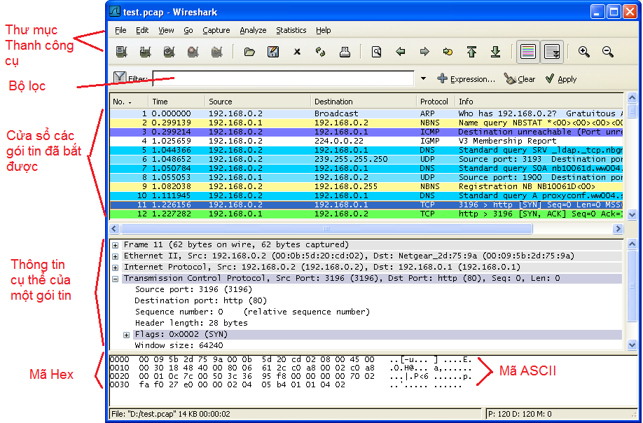
Figure 1. Wireshark interface.

- Users can interact with the application using functions in the applicant menu. File menu allows users to save packet data into files and open saved files. Functions in Capture menu allow users to catch network packets.
- Data packet window shows a list of data packet being caught. For each packet, it shows the packet number, timestamp, source and destination addresses and protocol.
- The window underneath shows the detail of a selected packet. The details include Ethernet frame, and IP datagram.
- The bottom window shows details of a packet in ASCII and hexadecimal format.
3. Practice with capturing packets
3.1 Preparation
- Open a Web browser
- Start Wireshark
- To start catching packets, go to Capture menu and choose Options. Wireshark Capture Options dialog will be displayed, as in Figure 2.
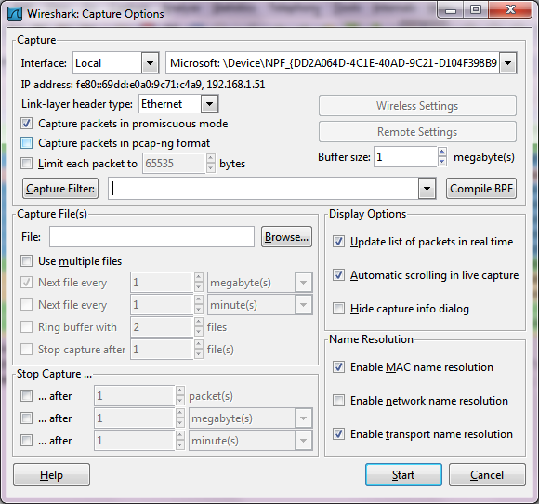
Figure 2: Select network interface
- We can use the default parameters shown in the dialog. In this dialog, we can select a network interface (at the top), from which we want to capture network data packets. After selecting the interface and parameters, click Start button to start the capturing process. All the packets coming in and out the interface will be captured.
- Once the capturing process started, a window that summarizes the capturing process is displayed, as in Figure 3. The window summarizes the number of data packets of different types.
- To stop the capturing process, click Stop button.

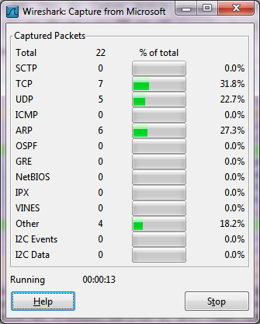
Figure 3. Capturing status window.
- While the capturing process is on, type in http://cse.hcmut.edu.vn into the browser and wait for the content of the web page fully displayed in the browser window. Ethernet frames that contain HTTP messages will be captured by Wireshark.
- When the browser fully displays the web page of the CSE, stop the capturing process. The capturing status window will be close, and the main Wireshark windows will display all the captured packets. The main windows at this time will look like figure 1. Examine the details of the captured packets to see what are in the captured packets.
- Type “http” into the filter on the top of main window, and then choose Apply, see what will happen.
- Select the first http message in the list of packets, analyze the content of this packet.

